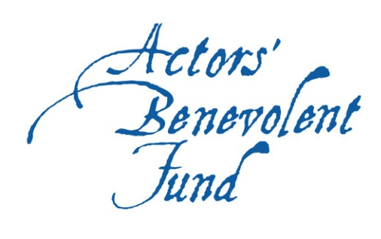
Become a Friend of the Actors’ Benevolent Fund

Thank you for registering to become a Friend of the ABF. With your help, we can continue our vital work supporting actors and stage managers experiencing hardship due to illness, injury or old age.

Our Friends help us to spread the word of the ABF so we can reach more people who need us. To say thank you, you will receive in return invitations to exclusive events, an annual newsletter from our President, and a discount at the ABF Christmas card store, all for a donation of just £10 per month, or £100 per year.

To become a Friend, please fill out the form below and return it to us, either via email to office@abf.org.uk, or by post to: Actors’ Benevolent Fund, 6 Adam Street, London WC2N 6AD.

Full name

Date of birth

Address

Postcode

Telephone number

Email address

Where did you hear about becoming a Friend of the Actors’ Benevolent Fund? (e.g. advert in theatre programme, word of mouth etc.)

From time to time we may wish to contact you to update you on our work and activities, and to send you our Friends’ newsletter. If you would like to be contacted in the future, please confirm your preferred contact method (delete as applicable) | Email / Telephone / Post

Mandatory Data Protection statement: The personal details you supply will be used to process your donation, and will not be passed on to any third party except for the sole purpose of facilitating this payment.
Please sign below indicating your agreement of these terms.

Your signature

Date

FRIENDSHIP FEE DETAILS

It’s easy to set up a Direct Debit via the ‘Support the ABF’ page on our website

Alternatively, fill out your details below:

Account number

Sort code

Name of account holder …………………………………………………………



Direct Debit Guarantee
- The Guarantee is offered by all banks and building societies that accept instructions to pay Direct Debits
- If there are any changes to the amount, date or frequency of your Direct Debit the Actors’ Benevolent Fund will notify you (normally 10 working days) in advance of your account being debited or as otherwise agreed. If you request the organisation to collect a payment, confirmation of the amount and date will be given to you at the time of the request
- If an error is made in the payment of your Direct Debit, by the organisation or your bank or building society, you are entitled to a full and immediate refund of the amount paid from your bank or building society
  - If you receive a refund you are not entitled to, you must pay it back when the organisation asks you to
- You can cancel a Direct Debit at any time by simply contacting your bank or building society. Written confirmation may be required. Please also notify us.

- - - - - - - - - - - - - - - - - - - - - - - - - - - - - - - - - - - - - - - - - - - - - - - - - - - - - - - - - - - - - - - - - - -

To pay £100 for one year of Friendship

Card number

Valid from / Expires /

Name on card …………………………………………………………

CVV code a (the last three digits on the card’s signature strip)

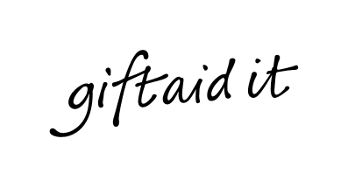
The Actors’ Benevolent Fund is a registered charity and can reclaim 25% of your friendship fee from HMRC if you are a UK taxpayer, through the Gift Aid scheme. Please enter your details below if you would like us to claim Gift Aid on this, and any future friendship fees you pay to us.

GIFT AID DECLARATION

I declare that all friendship fees made to the Actors’ Benevolent Fund by me, now and in the future, shall be treated as donations. I want to Gift Aid my donations to the Actors’ Benevolent Fund.

Name

Address

I am a UK taxpayer and understand that if I pay less income tax and/or capital gains tax in the current tax year than the amount of Gift Aid claimed on all my donations it is my responsibility to pay any difference.

Your signature
Date

